Cast List README

Ed Caruso

August 30,2014

This document is will explain how to add to the data files when you have the need to add new information to the Cast List webpage for the Laurel Little Theater website (<http://www.laurellittletheatre.com/casts.php5>)

In the directory where the site is stored you will see a directory and a file

1. Directory: casts
2. File: casts.php5

(Some web hosting companies want a file ending in .php and some want .php5. We have both and they are identical. Currently we use casts.php5)

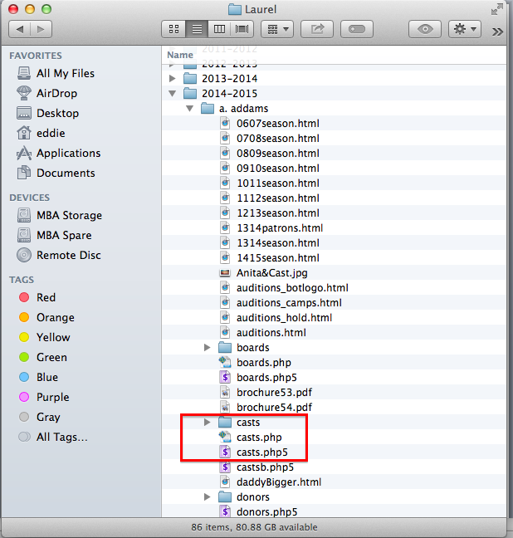

Inside the casts directory you will fine the data files used by the casts.php5 script to construct the cast list web page(s) as seen on the site.

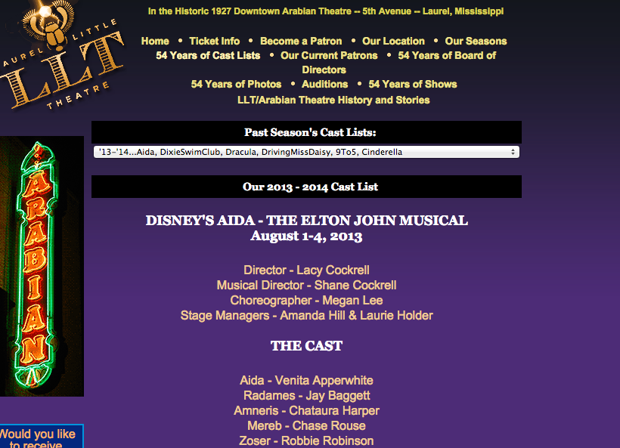

The nice thing about using a script like casts.php5, is that even though we have over 50 different cast lists, we use one program to construct and display any individual cast list. This helps with the pulldown menu that used to select a cast list to display. If we 50+ separate cast list pages, we would have to edit EACH of those files when a new year comes a long and a new cast list needs to added to the site. That is both time consuming and prone to programmer error. Not to mention, 90% of each page is repetitive in each cast list. Now the workload for the person maintaining the cast list is reduced to the following tasks (working in the casts directory)

1. Add to the pulldown.data file
2. Create and HTML document that need to be displayed when appropriate.

Contents of cast directory

1. file: pulldown.data
2. html files: An HTML document for each season. The pattern for the file name is important. When adding a new season, you must match the existing pattern <yyyyxxxx>cast.html. Where yyyy is the year the season begins, and xxxx is the year the season ends. Such as 20142015cast.htnml

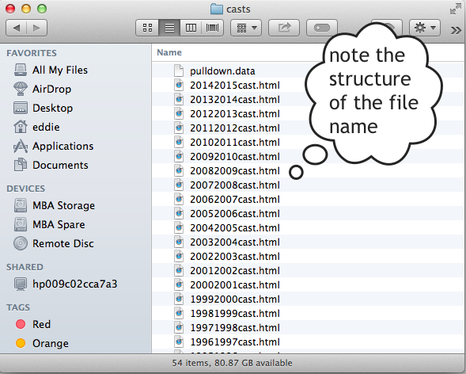

That said, the file 20142015cast.html is the html file that will be displayed when the users selects the

'14-'15...TheAddamsFamily, LittleWomen, TheGlassMenagerie, RedAndWhiteTuna, AladdinJr

item from the pulldown menu. This discussion has now introduced you to what files are involved and where they are stored. Now lets discuss the CONTENT of the files and how to add to them to when necessary so a new cast list can be added to the site.

As you know, there is a file that contains the pulldown menu for the cast list page. Again, instead of having to edit the HTML for the pulldown menu in 50+ cast html files, you only need to edit ONE data file and the pulldown menu will be up to date for ALL CAST LIST. Five minutes of work instead of possibly HOURS.

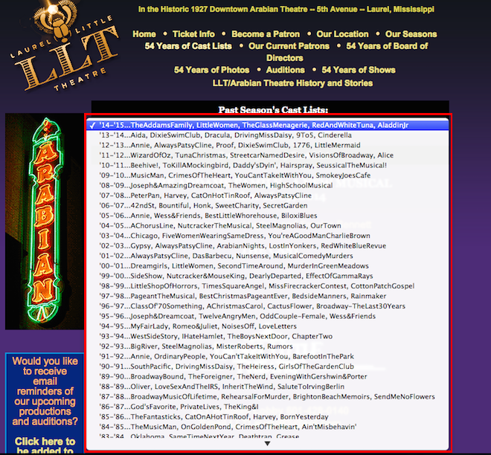

Let’s look at the contents of the pulldown.data file in the casts directory. This is just a sample but you will get the idea.

A B

20142015|'14-'15...TheAddamsFamily, LittleWomen, TheGlassMenagerie, RedAndWhiteTuna, AladdinJr

20132014|'13-'14...Aida, DixieSwimClub, Dracula, DrivingMissDaisy, 9To5, Cinderella

20122013|'12-'13...Annie, AlwaysPatsyCline, Proof, DixieSwimClub, 1776, LittleMermaid

20112012|'11-'12...WizardOfOz, TunaChristmas, StreetcarNamedDesire, VisionsOfBroadway, Alice

20102011|'10-'11...Beehive!, ToKillAMockingbird, Daddy'sDyin', Hairspray, SeussicalTheMusical!

20092010|'09-'10...MusicMan, CrimesOfTheHeart, YouCantTakeItWithYou, SmokeyJoesCafe

20082009|'08-'09...Joseph&amp;AmazingDreamcoat, TheWomen, HighSchoolMusical

20072008|'07-'08...PeterPan, Harvey, CatOnHotTinRoof, AlwaysPatsyCline

20062007|'06-'07...42ndSt, Bountiful, Honk, SweetCharity, SecretGarden

20052006|'05-'06...Annie, Wess&Friends, BestLittleWhorehouse, BiloxiBlues

20042005|'04-'05...AChorusLine, NutcrackerTheMusical, SteelMagnolias, OurTown

20032004|'03-'04...Chicago, FiveWomenWearingSameDress, You'reAGoodManCharlieBrown

20022003|'02-'03...Gypsy, AlwaysPatsyCline, ArabianNights, LostInYonkers, RedWhiteBlueRevue

The format of file is as follows

1. The year portion in 8 digits for the season such as 20142015. You will see this is used to tell the php script what datafile to put on screen when the ’14-’15 season is chosen. In this cast you would get 20142015cast.html
2. This is the text that is displayed IN THE PULLDOWN MENU

The two columns are separated by a vertical bar (pipe character ‘|’). This is a must.

The only other point to consider is that the pulldown menu is constructed as listed in the file. No sorting of the data takes place. So. Always insert a new season in the correct place in the list.

In our example to add 2015 – 2016 season, you would add it to the TOP of the pulldown.data file as shown below:

A B

**20152016|'15-'16...Eddie, Bart, West**

20142015|'14-'15...TheAddamsFamily, LittleWomen, TheGlassMenagerie, RedAndWhiteTuna, AladdinJr

20132014|'13-'14...Aida, DixieSwimClub, Dracula, DrivingMissDaisy, 9To5, Cinderella

20122013|'12-'13...Annie, AlwaysPatsyCline, Proof, DixieSwimClub, 1776, LittleMermaid

20112012|'11-'12...WizardOfOz, TunaChristmas, StreetcarNamedDesire, VisionsOfBroadway, Alice

20102011|'10-'11...Beehive!, ToKillAMockingbird, Daddy'sDyin', Hairspray, SeussicalTheMusical!

20092010|'09-'10...MusicMan, CrimesOfTheHeart, YouCantTakeItWithYou, SmokeyJoesCafe

20082009|'08-'09...Joseph&amp;AmazingDreamcoat, TheWomen, HighSchoolMusical

20072008|'07-'08...PeterPan, Harvey, CatOnHotTinRoof, AlwaysPatsyCline

20062007|'06-'07...42ndSt, Bountiful, Honk, SweetCharity, SecretGarden

20052006|'05-'06...Annie, Wess&Friends, BestLittleWhorehouse, BiloxiBlues

20042005|'04-'05...AChorusLine, NutcrackerTheMusical, SteelMagnolias, OurTown

20032004|'03-'04...Chicago, FiveWomenWearingSameDress, You'reAGoodManCharlieBrown

20022003|'02-'03...Gypsy, AlwaysPatsyCline, ArabianNights, LostInYonkers, RedWhiteBlueRevue

So, we are half way done with the addition. Now in our example you would need to create an html document to be display for that new menu choice. I would suggest, make a copy of an existing file and modify it to be correct for your new season … Remember to use the proper file name pattern mentioned earlier in our example you would want 20152016cast.html

First, using a portion of the 20132014cast.html file I can show you what we usually work with.

<a name="aida"></a>

<p class="show">DISNEY'S AIDA - THE ELTON JOHN MUSICAL<br />August 1-4, 2013</p><br />

Director - Lacy Cockrell<br />

Musical Director - Shane Cockrell<br />

Choreographer - Megan Lee<br />

Stage Managers - Amanda Hill & Laurie Holder<br />

<br />

<p class="show">THE CAST</p><br />

Aida - Venita Apperwhite<br />

Radames - Jay Baggett<br />

Amneris - Chataura Harper<br />

Mereb - Chase Rouse<br />

Zoser - Robbie Robinson<br />

Nehebka - Sarah Rice<br />

Pharaoh - Rick Bennett<br />

Amonasro - Wilson Rice<br />

<br />

<span style="text-decoration:underline">

THE ENSEMBLE

</span>

<br />

JD Bilbo, Austin Bounds, Essence Collier, Laura Cooley, Danielle Davis,<br />

Natalie Dewitt, Madisone Hatten, Yancy Hearn, Bailey Hill, Will Hodges,<br />

Haleigh Holder, Zaria Husband, Shamayia Keyes, Alexander Knight,<br />

Kody Loper, Katie Quinnell, Jamie Leigh Rambin, Lativia Rogers,<br />

Ben Smith, Nina Thigpen, Tabitha Walls, Alison Vanderslice,<br />

Zoe Vanderslice, Luke Youngblood<br />

<br />

<span style="text-decoration:underline">

THE CHORUS

</span>

<br />

Frankie Bennett, Rick Bennett, Cherie Boone, Katelyn Bryant,<br />

Landon Bryant, Gail Chancellor, Angie Hodge, Brandiilyn Irvin,<br />

Susan Mangum, CindyRobinson, Missy Sanderson, Jackie Thomas<br />

<br />

<hr>

<br />

The format for what is shown is JUST typical HTML elements or javascript etc..

Points of interest... An individual show section starts with in a link that can be used to send you to the section that focuses on that show…. So you can jump to any show on the page.

<a name="aida"></a>

Then you have the HTML for the show, including and image of the logo for the show, dates, directors and a blurb about the show. The section for any one show on the page typically ends with a blank line after the ‘blurb’, a horizontal bar and another blank line.

<br />

<hr>

<br />

The HTML for the next show follows, repeating this general pattern. Studying an existing file will make this more clear.

One item to notice the blank line, horizontal bar, blank line IS NOT at the bottom of the file after the last show in the list. It is not needed.

At the time of this writing, the 20142015cast.html is BRAND new for the 2014-2015 season. I have included it as an example of a small html document. Remember this is JUST the cast information for the season. All the surrounding display is handled by the php script… the top of the page with the navigation menu choices, etc.

<a name="addams"></a>

<p class="show">THE ADDAMS FAMILY - A NEW MUSICAL<br />October 16-19, 2014</p><br />

Directors: Wess Hughes and Frankie Bennett<br />

<br />

<p class="show">THE CAST</p><br />

<br />

<!--

<span style="text-decoration:underline">

THE ENSEMBLE

</span>

<br />

names

<br />

<span style="text-decoration:underline">

THE CHORUS

</span>

<br />

names

-->

As shown, the Addams Family is mostly just a placeholder as no information for casted actors is available yet. Also as there are no other shows in the file yet, and the blank line, horizontal bar, blank line is NOT coded at the bottom of the file

See next page….

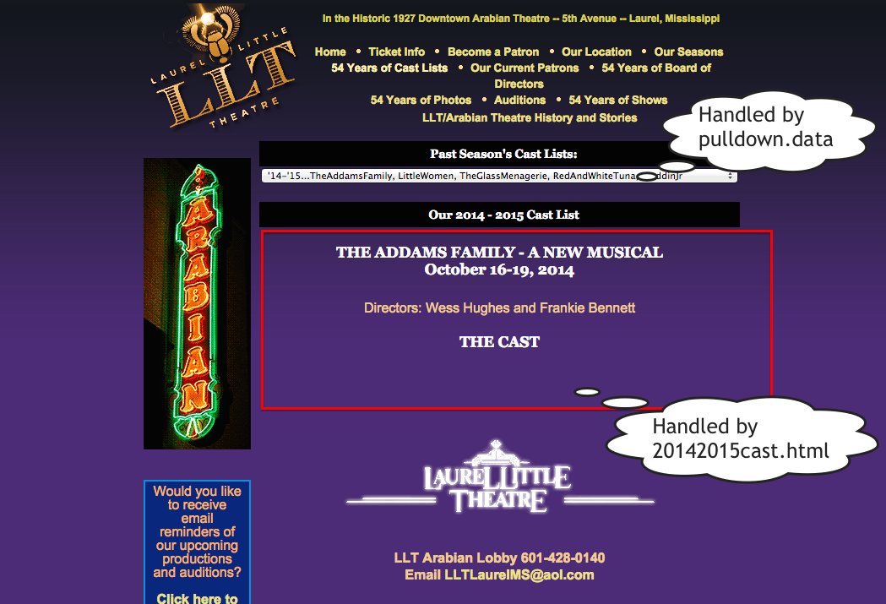

1. The Pulldown menu is handled by the pulldown.data file
2. The material in the red box is HTML coded in the yyyyxxxxcast.html flle
3. All the rest (outside the red box) is coded In the casts.php5 script…. Even the logic to construct the pulldown menu based on the data in the file, is handled by the casts.php5 script.